**NAME: Maaz Habib**

**REGISTRATION NUMBER:20PWCSE1952**

**DEPARTMENT: DCSE**

**SEMESTER:3rd SEMESTER**

**SECTION: C**



**CIRCUITS AND SYSTEM-II LAB**

**CS-II LAB #8 REPORT**

**SUBMITTED TO: ENGR FAIZ ULLAH**

**LAB# 8**

**OPERATIONAL AMPLIFIER APPLICATIONS-INVERTING SUMMING AMPLIFIER AND DIFFERENCE AMPLIFIER**

**OBJECTIVES:**

To demonstrate the use of Operational Amplifier for performing mathematical operations of summation and difference.

**EQUIPMENT:**

1. DC Power Supply

2. Oscilloscope

3. Function Generator

COMPONENTS:

1. LM 741 Op-amp

2. 47kΩ

3. 100kΩ

**Part A**

**Inverting Summing Amplifier**

**Theory Overview**

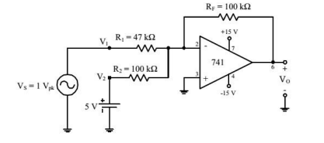

**FIGURE 1**

The above fig (1) shows an example of how an operational amplifier is connected to perform voltage summation. In this figure, an ac and a dc voltage are summed.

**Formula:**

In general, output voltage Vo for inverting summing amplifier is calculated using the following formula:

**Vo=-(Rf/R1V1 + Rf/R2V2)**

**PROCEDURE:**

1. To demonstrate the use of an operational amplifier as a summing amplifier, connect the circuit of Figure 1.

2. With Vs adjusted to produce a 1 V peak sine wave at 1 kHz, observe the output voltage VO (and VS to note the phase relationship) on an oscilloscope set to dc input coupling.

3. Sketch the output voltage waveform. Be sure to note the dc level in the output.

4. Interchange the 5 V dc power supply and the 1 V peak signal generator.

5. Repeat procedure step 2 and observe the change in output waveform.

**Circuit diagram:**

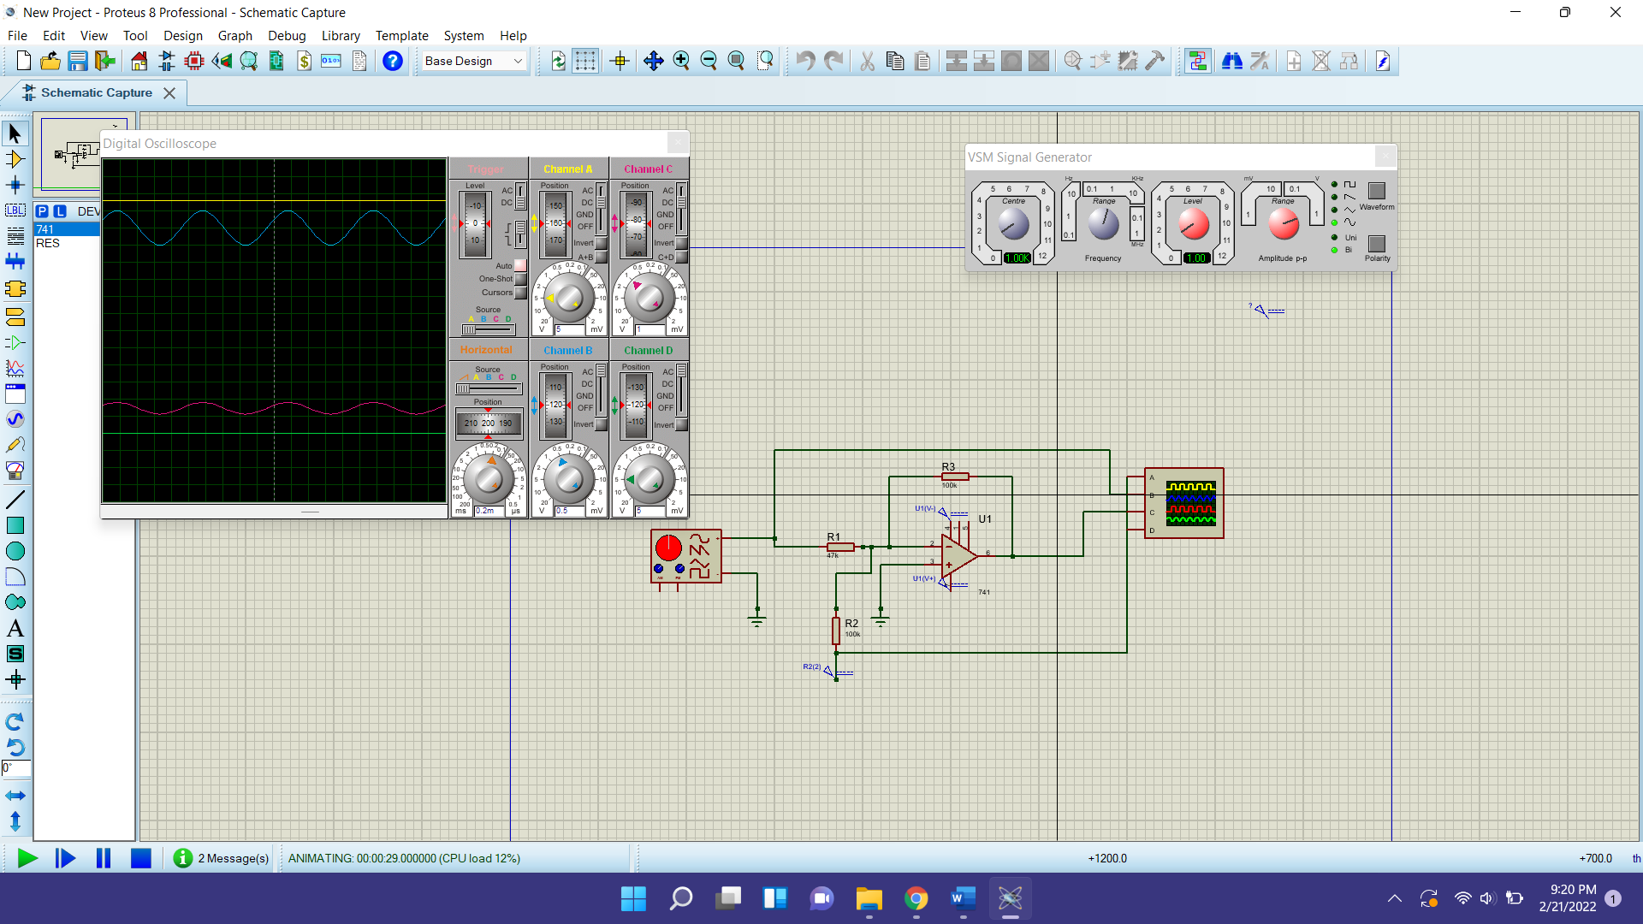

**TABLE 1 FOR INVERTING SUMMING AMPLIFIER:**

|  |  |  |  |  |
| --- | --- | --- | --- | --- |
| **V1(V)** | **V2(V)** | **Vo(theoretically)** | **Vo(experimentally)** | **%deviation** |
| **2** | **6** | **-4.24V-6V** | **-4V-6V** | **0%** |
| **1.5** | **4** | **-3.18V-4V** | **-3V-4V** | **0%** |
| **2.5** | **5** | **-5.3V-5V** | **-5.3V-5V** | **0%** |
| **3** | **-3** | **-6.36V+3V** | **-6.3V-3V** | **0%** |
| **1** | **-2** | **-2.12V-2V** | **-2V-2V** | **0%** |

**PART B**

**DIFFERENCE AMPLIFIER**

**THEORY OVERVIEW:**

A difference amplifier has two inputs and the output voltage is proportional to the voltage difference of the input voltages. In fact, the (open-loop) Op-Amp itself is a difference amplifier, except that the gain is ideally infinity. Here we want a difference amplifier with finite gain. One such circuit using a single OpAmp is shown in Figure 4. It can be shown that the gain of the difference amplifier can be calculated using the following:

**CIRCUIT DIAGRAM FOR DIFFERENCE AMPLIFIER:**

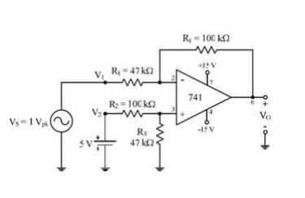

**Figure 2**

Output voltage V0 for difference amplifier is calculated using the following formula:

V0=(V2(1+Rf/R1)(R3/R2+R3))-(Rf/R1*V1)

This equation can be simplified by making R3= Rf= R1= R2, yielding a simple differential amplifier with unity

gain: V0=V2-V1

**Procedure:**

1. To investigate the use of an operational amplifier in a difference amplifier configuration, connect the circuit of Figure 2.

2. With VS adjusted to produce a 1 V peak sine wave at 1 kHz, observe the output voltage VO(and VS to note the phase relationship) on an oscilloscope set to dc input coupling.

3. Sketch the output voltage waveform. Be sure to note the dc level in the output.

4. Interchange the 5 V dc power supply and the 1 V peak signal generator.

5. Repeat procedure step 2 and observe the change in output waveform

**TABLE FOR DIFFERENCE AMPLIFIER:**

|  |  |  |  |  |
| --- | --- | --- | --- | --- |
| **V1(V)** | **V2(V)** | **Vo(theoretically)** | **Vo(experimentally)** | **%deviation** |
| **1.8** | **5** | **5V-3.82V** | **5V-3.8V** | **0.523%** |
| **2.2** | **5** | **5V-4.664V** | **5V-4.7V** | **0.765%** |
| **2.5** | **5** | **5V-5.3V** | **5V-5.3V** | **0%** |
| **2.9** | **5** | **5V-6.148V** | **5V-6.2V** | **1.1%** |
| **3.2** | **5** | **5V.6.784V** | **5V-6.8V** | **0.5%** |